**UMKA NEWSLETTER**

**UMKA CARDBOARD MILL:**

**Sustainable business and responsible management of recovered paper**

**What makes our Mill a friend of the environment is the fact that we use only recovered paper as the basic raw material for the production of high-quality cardboard. For production purposes, about 160,000 tons of recovered paper are collected and processed annually, which would have ended up in municipal landfills.**

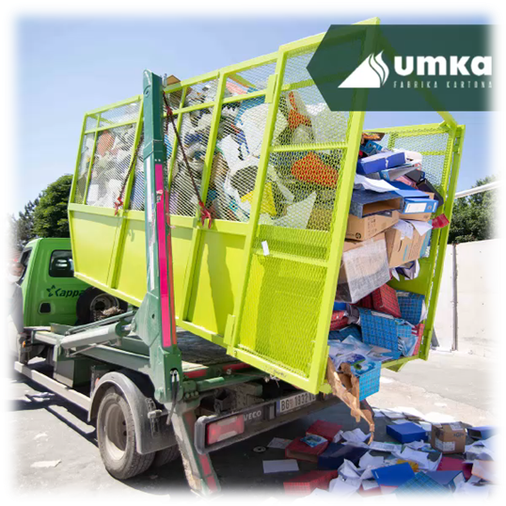**Guided by the basic principles of sustainable development, we constantly invest in environmental protection, which is reflected in respecting the hierarchy of waste management, separating waste at the point of origin, in reducing the consumption of raw materials and energy, replacing raw materials with more environmentally friendly raw materials in the production process where possible.** **If we recycled more paper and cardboard, or at least as much as we consume, our environment would be a cleaner, greener and healthier place to live.**

**What is recovered paper made of?**

* **Archival paper,**
* **Cardboard from the supermarket,**
* **Newsprint,**
* **Shipping boxes,**
* **Outdated textbooks**

**Since 2003 and the process of privatization, our Mill has quadrupled the amount of recovered paper processing and, accordingly, the production of cardboard from 45,000t to 160,000t yearly.**

**We are moving steadily and step by step towards the production of 200,000 tons per year.**

**The beginning of September and the beginning of the new school year**

**The first of September is an extremely important day for student champions 👩‍🎓🧑‍🎓 and their parents. That's why all employees of the Umka Cardboard Mill, parents of children starting first grade, have the right to use the day off on that day in order to spend it carefree with their children.**

**The Umka cardboard Mill congratulates the little schoolchildren of our colleagues on starting school with a gift voucher for the purchase of school supplies. We wish all children a happy start to school!**

**NEWS AND TRENDS:**

**The energy crisis continues to shake the economy**

**The energy crisis continues to shake all the countries of the European continent. The extremely strong summer affected the drop in the level of all river flows in Europe. Countries that depend on energy based on hydropower could not count on that energy this summer. Taking into account that the summer was extremely hot, even more electricity was needed for cooling than usual, so this factor also had an additional impact on the lack of electricity. When we add the energy crisis caused by the war in Ukraine, the shortage and rising prices of oil and gas to such an already weakened energy system, we can say with certainty that ours is in for a very turbulent winter.**

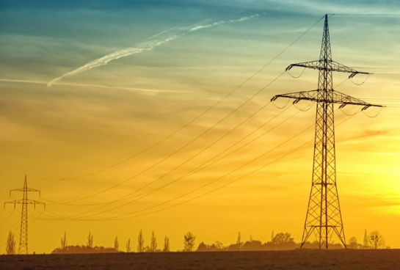**At times, it seems that everything that could go wrong in terms of energy, did. Coal, pellets, gas, wood for firewood are the items that have been the most sought after and talked about the most recently.** **The only thing we can hope for right now is that the winter won't be as extreme as the summer.**

**International monetary fund economists estimate that the increase in fossil fuel prices will triple households’ expenditure on energy in 2022. As consequence of the rising cost of input fuels, benchmark electricity prices in Europe have surged almost 300% in 2022, breaking records. Taken together, energy prices are ten times higher than the five-year average.**

In order to reduce the effect of rising prices of all energy and raw materials, economists must find as soon as possible a way to tame the growing inflation that affects every household and every transaction. Continuous turbulence on the market of raw materials and energy products leads all economic agents to be very careful when making decisions. Maintaining a stable supply chain, stable deliveries, meeting deadlines and fulfilling the agreed upon currently seems like an ever more difficult task.

In a situation of shortage of energy sources and other raw materials necessary to maintain production, many production factories decide on temporary stoppages in production. Periodic shutdowns also manage to make savings in electricity and gas consumption, so that deficiencies and shortages are distributed and available during the winter.

Our Mill continues to work with the same intensity and pace as we have been doing all these years. In these difficult times, we try and do our best to maintain a stable level of production and investment in our plants. What we promise and agree with our partners, we try as we have always tried to meet the deadlines and agreed conditions. That's how we've worked until now and that's how we'll continue to work, as long as we're able to.

**Interesting stories**

In Q3 2022 we managed to deliver our products to 40 countries and 222 customers across Europe, North America, Africa and Middle East. Our products were shipped to Netherlands, Germany, Poland, Cameroon, Tunisia, Israel and Mexico among others.

Depending on the transportation possibilities, pandemic issues and all other relevant factors, we will continue to adapt and follow latest market trends and limitations caused by the supply chain disruptions and war in Ukraine.

Thank you for your trust and cooperation!

**If you have questions or inquires please contact us**

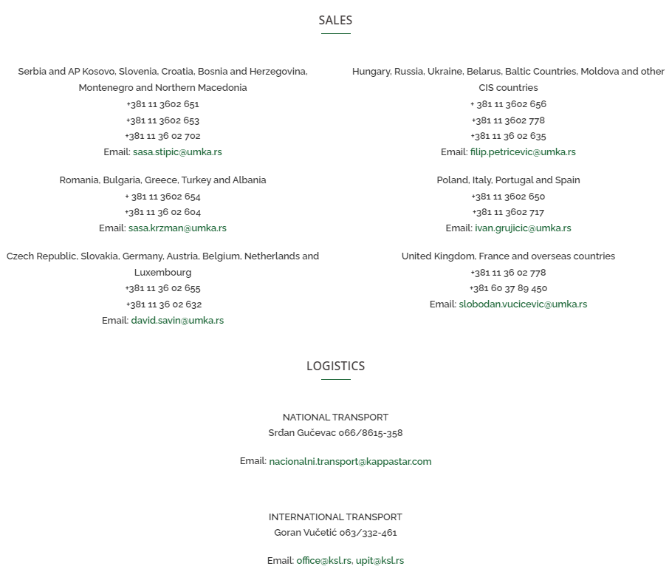

**Sincerely,**

**UMKA TEAM**